User Manual

Deep Learning-based Underbody Vehicle Automated Wireless Inspection System

Table of Contents

1.0 Startup 3

1.0 Inspection System 3

1.1 Homepage 3

1.2 Data Collection 4

1.3 Image Object Detection 5

1.4 Bulk Image Object Detection 8

1.5 Video Object Detection 11

1.6 Capture Object Detection 13

1.7 Live Object Detection 17

# Setup

Take Notes:

Jetson Username: vwpekan

Jetson Password: 1234

MySQL Root Username: root

MySQL Root Password: vwpekan

MySQL Username: ben

MySQL Password: vwpekan_1118

MySQL Database name: vwDB

1. Switch on Jetson Orin Nano, Raspberry Pi Zero and data hotspot.
2. Make sure Jetson Orin Nano is connecting with monitor screen, keyboard and mouse.
3. Check the date and time of Jetson Orin Nano to make sure it is correct, adjust if it is not.
4. Wait for the Raspberry Pi Zero to connect with data hotspot by checking the device that provides the hotspot.
5. After both the Raspberry Pi Zero have been connected to the data hotspot, open up the inspection codes from PyCharm and run the following command:  
   “streamlit run .\1_Homepage.py”
6. Startup Preparation is ready.

# Inspection System

## Homepage

Project explanation regarding which type of vehicle model to check and what type of checking are we looking at. Further information would be the equipment used and software stack explanation that we used for the creation of this project.

At the side bar, we can navigate to other webpages be clicking anyone of those based on figure below.

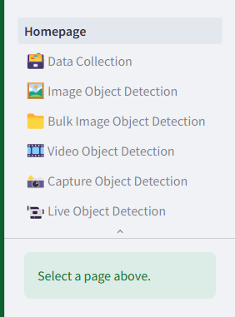

Figure 2.1 Side bar webpages

## Data Collection

Data webpage which displays all the data recorded and stored from each detection feature (image, bulk, video, capture and live). The data are displayed in the table and monthly bar chart, the beginning of the webpage is a bar chart that was based on the total amount of status regarding the vehicle based on months as shown in figure 2.2. Furthermore, we can filter out the results by inputting the parameters at the side bar as shown in figure 2.3.

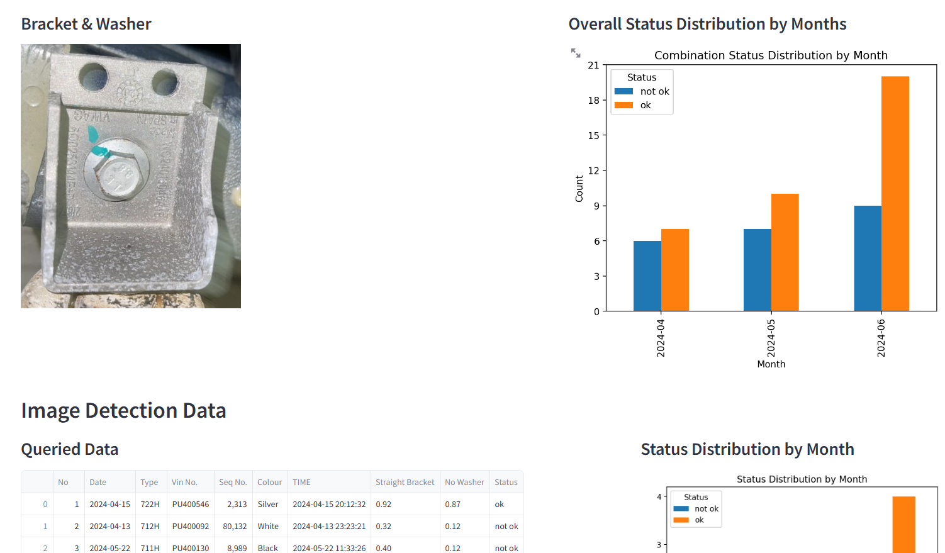

Figure 2.2. webpage that shows the overall status distribution by months

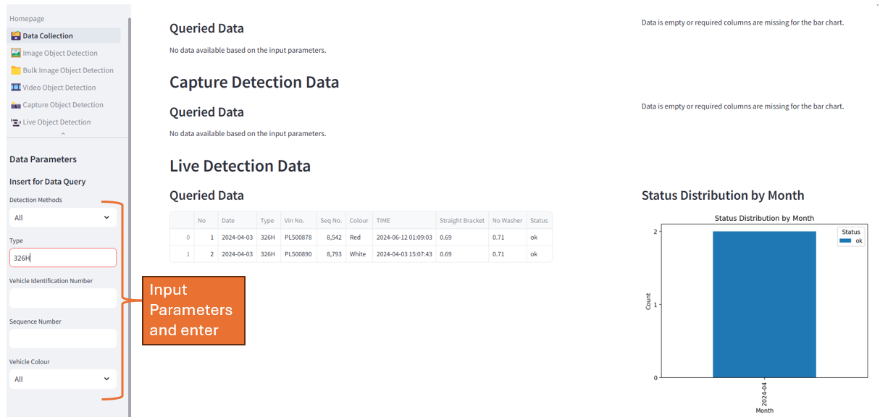

Figure 2.3. Input parameters for query data

## Image Object Detection

Webpage for single image object detection, beginning with showing us the data results displayed in table and bar chart as shown in figure 2.4.

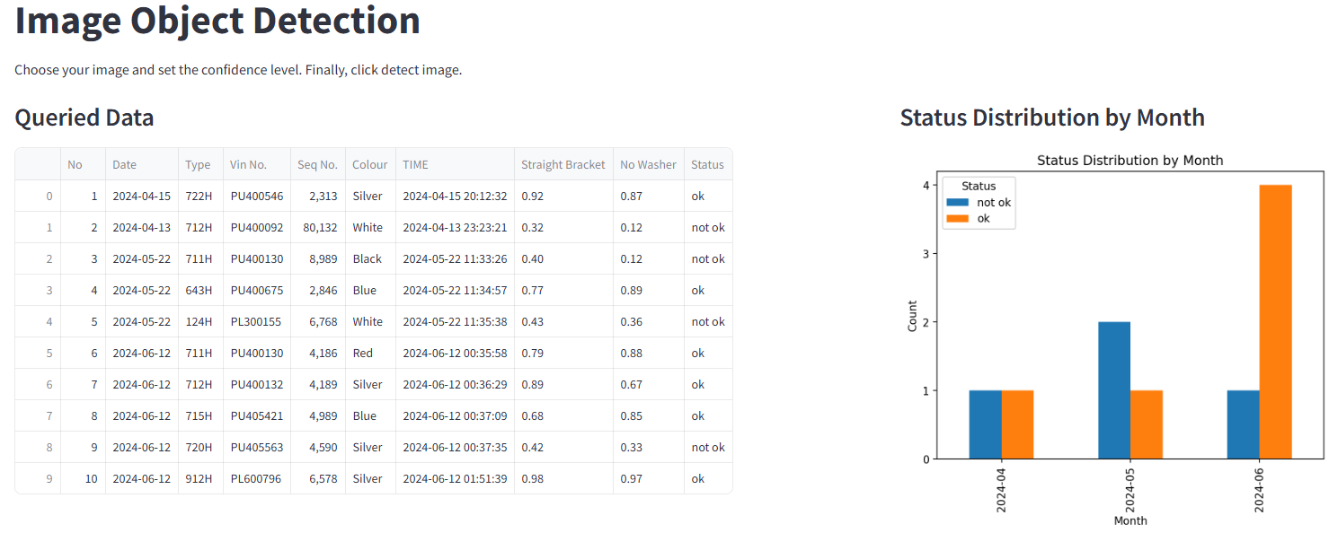

Figure 2.4 Data table and bar chart displayed

The steps for using the page will be explained as follows:

1. Drag our image to the side bar upload icon or click the “Browse files” button to select the image we want.
2. We will be able to see the image we uploaded at the sidebar and the main page of our webpage.

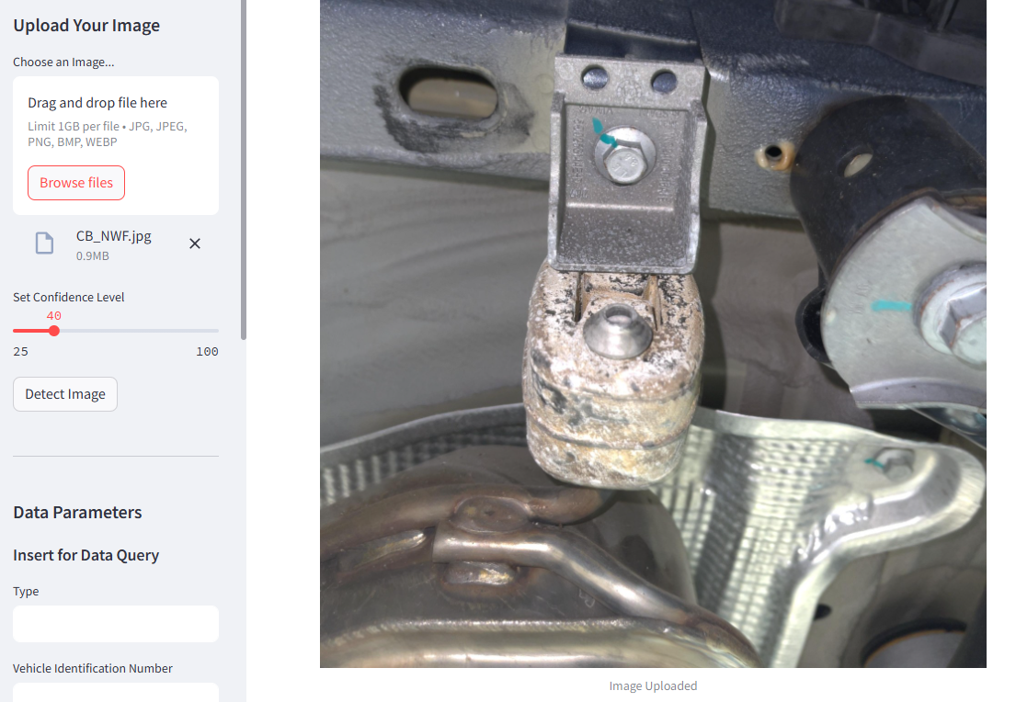

Figure 2.5 Image uploaded

1. Adjust the confidence level to desired value.
2. Press the detect image button at the left sidebar as shown in figure 2.6 to undergo defect inspection on the bracket and washer friction of the image.

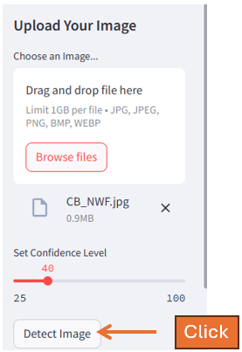

Figure 2.6 Detect image button at the side bar

1. The detected results will be displayed at the right side of the original image uploaded as shown in figure 2.7.

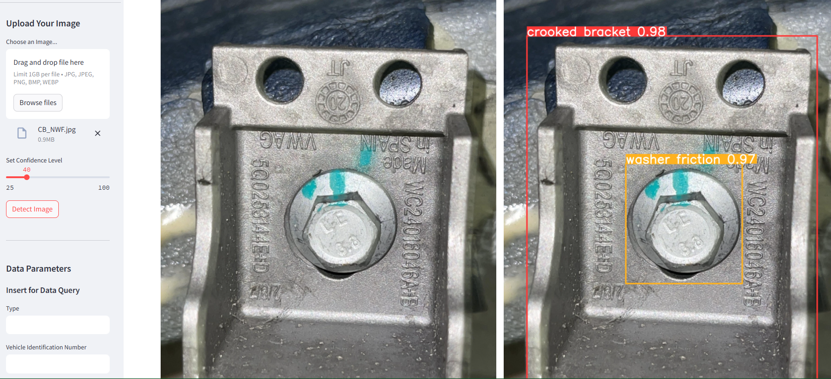

Figure 2.7 Detected result image

1. We can view the information we obtained from the image at the bottom right corner and download the detected result image by pressing the download image button as shown in figure 2.8. The image will be downloaded in a zip file.

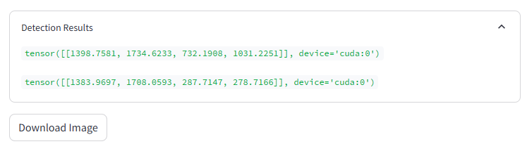

Figure 2.8. Detected result information and download button

1. After that, we can save the vehicle information and detected results into our database by inserting the data at the sidebar as shown in figure 2.9 and press the submit button after inserting everything to save the data. The data table and bar chart shown as in figure 2.4 will be refreshed and display the latest data entered.

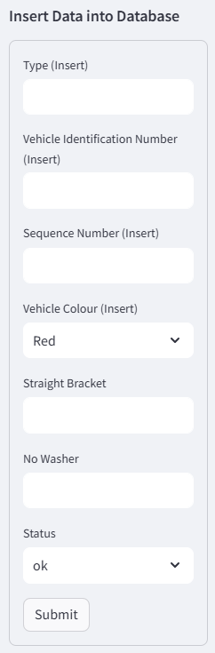

Figure 2.9 Parameter input for data storing

## Bulk Image Object Detection

Webpage for a bunch of images to be detected, this could ease us up as we can do defect inspection in one go for various different images. Furthermore, we are able to download the detected results in a zip file.

1. Beginning with the data table and bar chart displayed as shown in figure 2.10, we can filter the data table by inserting certain parameters in the query data input slot at the side bar and press enter as shown in figure 2.11.

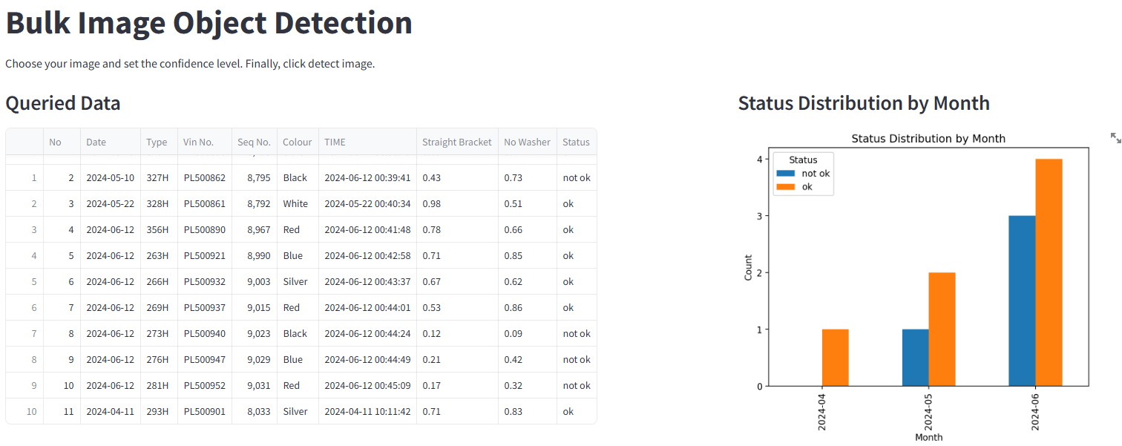

Figure 2.10 Data and bar chart displayed for bulk image

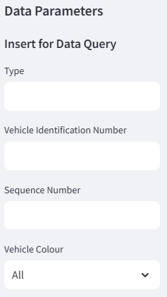

Figure 2.11 Data query for bulk image

1. To start defect inspection, we can begin by uploading multiple images or drag multiple images to the upload slot as shown in figure 2.12. The images uploaded will be displayed at the main page as shown in figure 2.13.

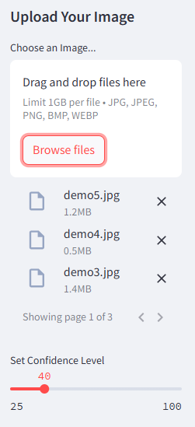

Figure 2.12 Upload slot for multiple images

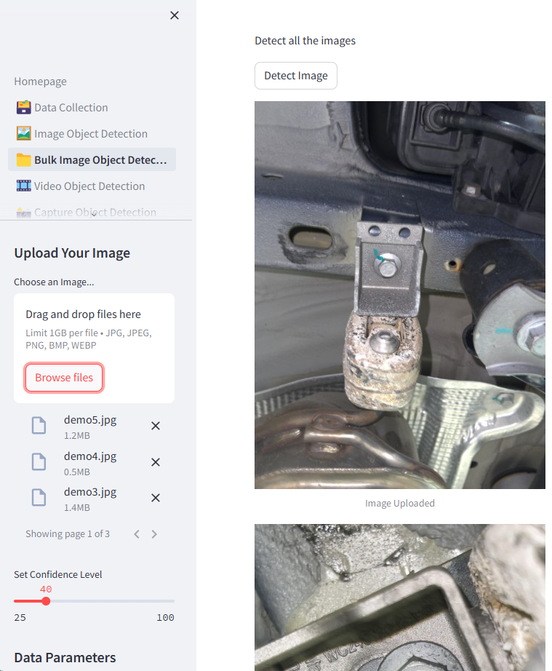

Figure 2.13 Uploaded images display

1. Once the images are uploaded, we can adjust the confidence level to our desired value which the model will detect based on that confidence level.
2. After that we can press the “Detect Image” button as shown in figure 2.13 which is above the first uploaded image to start the detection. The images uploaded will start to be detected and the detected image results will be displayed at the right side as shown in figure 2.14.

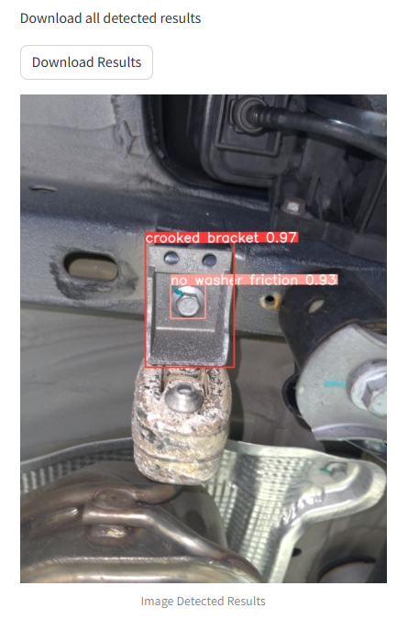

Figure 2.14 Detected image result with download button

1. After the detected image results have been displayed completely or finished detecting, there will be a “Download Results” button pop up which is for us to download all the detected image results in a zip once we clicked the button.
2. After that, we can key in the detected results at the side bar as shown in figure 2.15 along with the vehicle information we a click of a submit button.

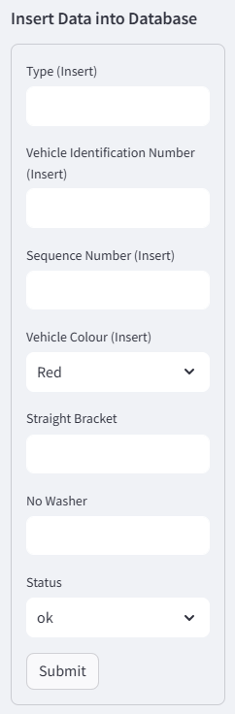

Figure 2.15 Data storage for Bulk Image

## Video Object Detection

Webpage for detecting defects from video footage.

1. Beginning with data displayed in a table and monthly bar chart which we can query by inserting the parameters at the side bar as shown in figure 2.16.

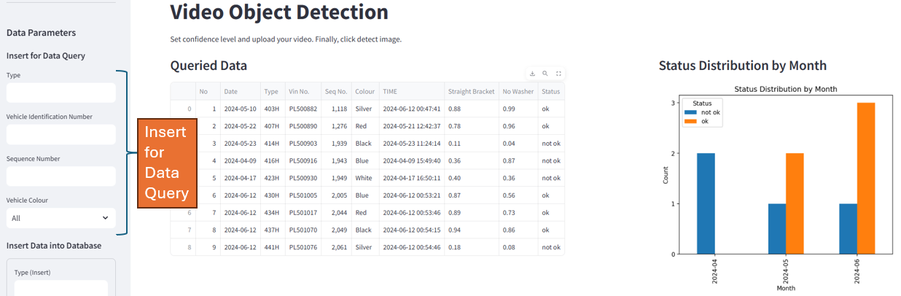

Figure 2.16 Data displayed and query

1. To detect the video footage, we must first upload the video footage to the upload slot as shown in figure 2.17. The video footage will be displayed in the side bar and also the main page of the webpage.

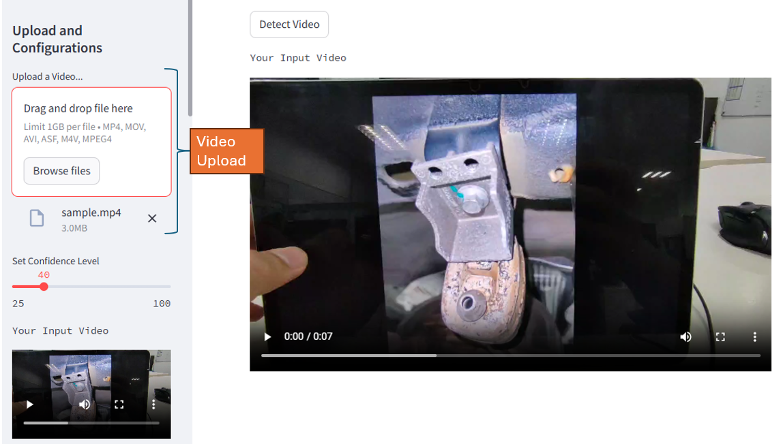

Figure 2.17 Video footage uploaded

1. Once the video has been uploaded, we can adjust the confidence value for the model to detect.
2. After that, we can pressed the “Detect Video” button to start the detection as shown in figure 2.18. There will be another video displayed at the right side of the original video footage which is the detected video footage, we will saw another video running with model detecting the video in figure 2.18.

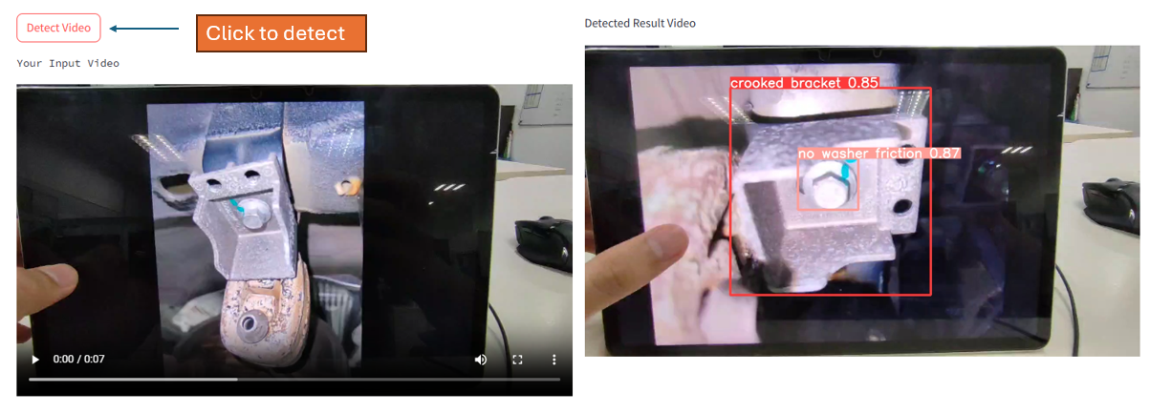

Figure 2.18 Model video detecting

1. Finally, we can insert the detected results in the task bar as shown in figure 2.19 to store the data inside the database with the submit button.

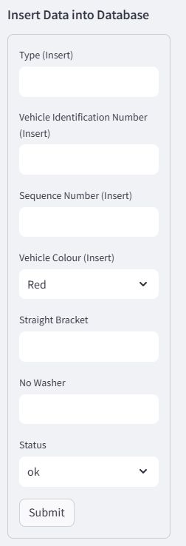

Figure 2.19 Data insert for storing

## Capture Object Detection

Webpage for real-time camera capture defect inspection with a press of a button as shown in figure 2.10. It sends signal to Raspberry Pi Zero to trigger the python code for taking picture with the camera that is connected to it, then it will send the image back to the Jetson Orin Nano to do defect inspection.

1. Beginning with the data table and bar chart displayed as shown in figure 2.20 which we can filter the data table by inserting certain parameters in the query data input slot at the side bar as shown in figure 2.21.

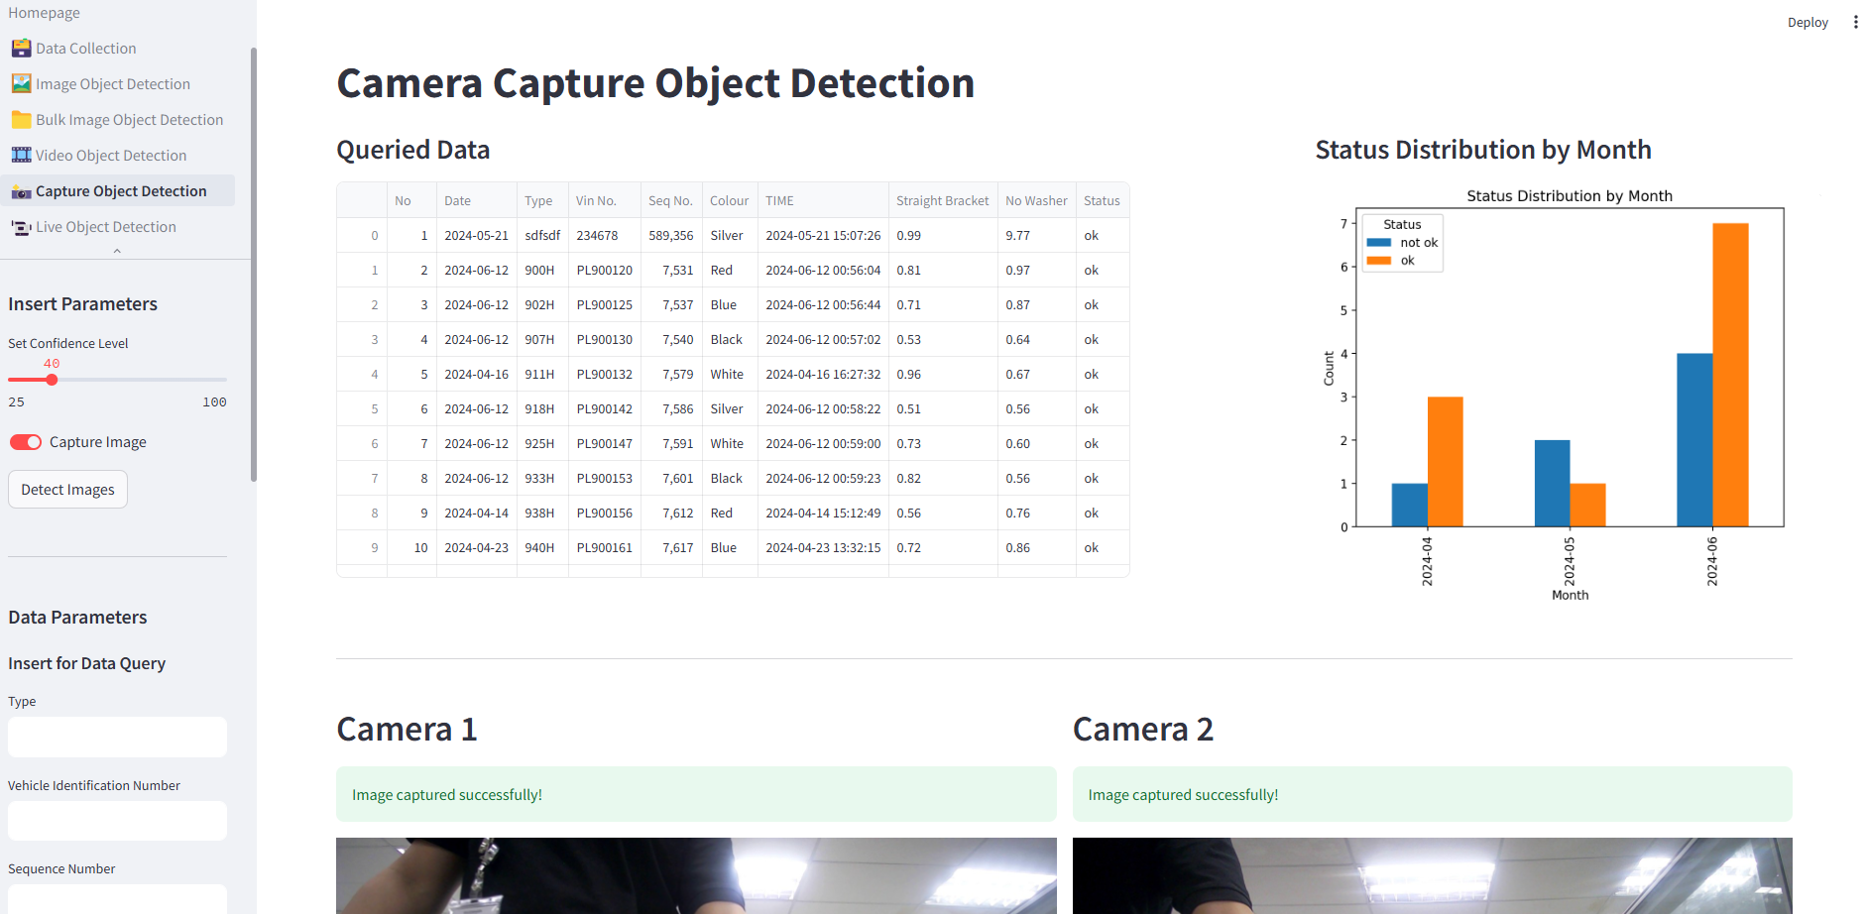

Figure 2.20 Data and bar chart displayed

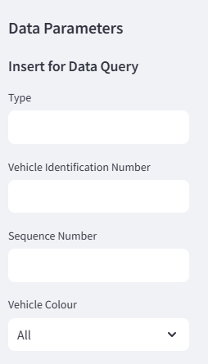

Figure 2.21 Data query parameters

1. To do defect inspection, we have to adjust the confidence level to our desired value as shown in figure 2.22.

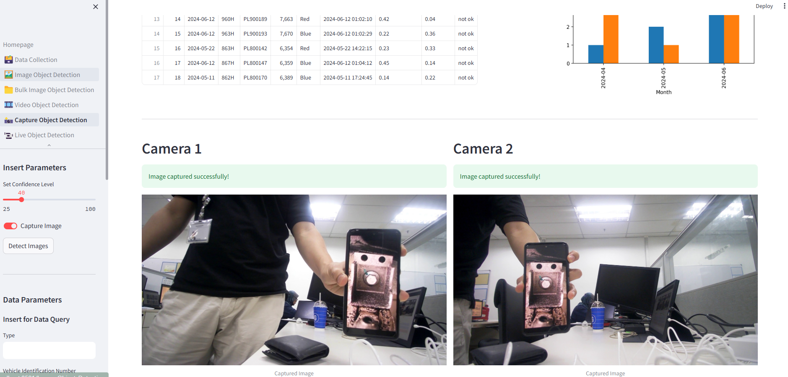

Figure 2.22 Camera taking picture

1. After that, we switch on the camera by toggle the switch “Capture Image”. If the camera is functioning then the camera will take a picture and displayed it out as shown in figure 2.23, else it will show the error.

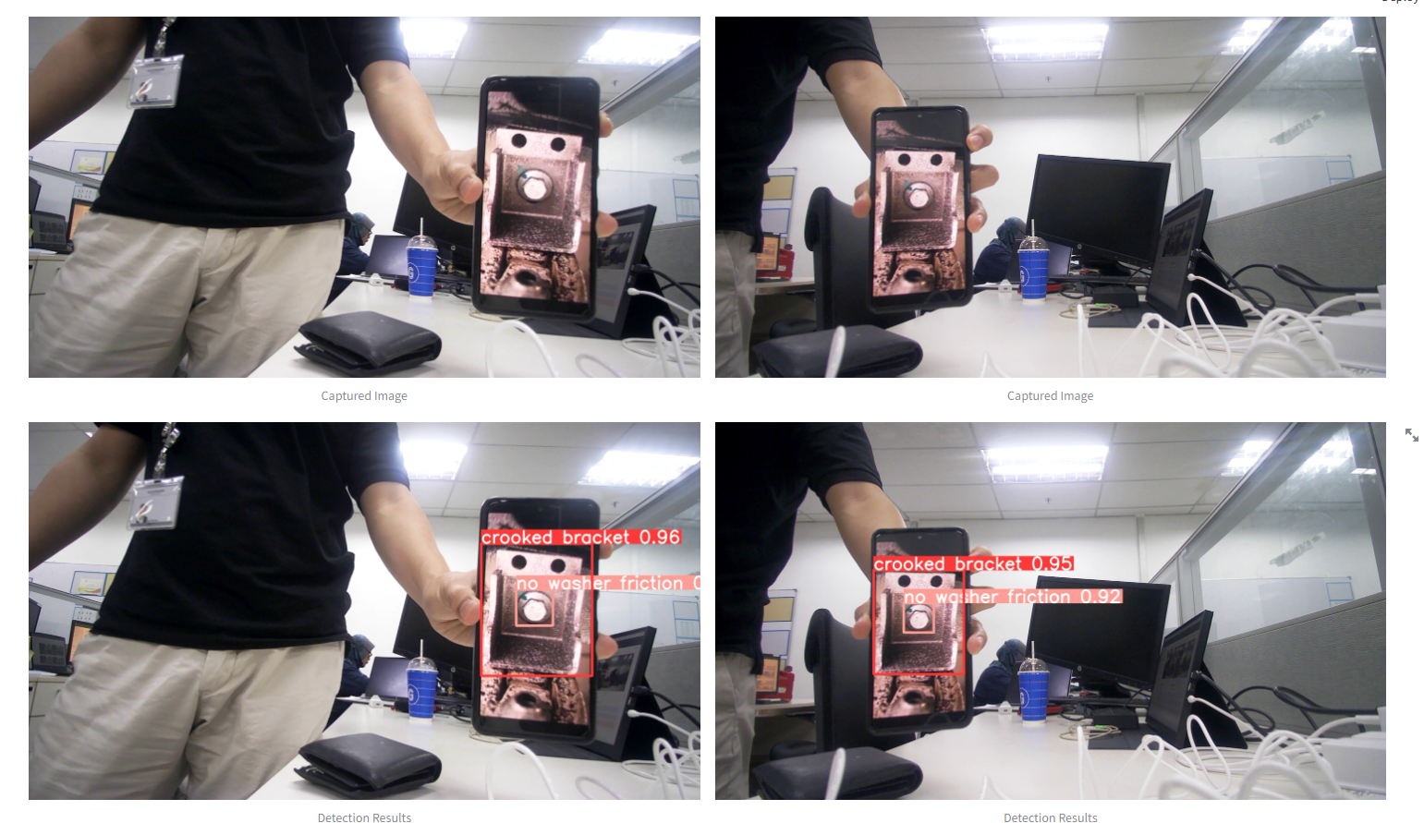

Figure 2.23 Detected image displayed

1. Once the camera is functioning and showing pictures, then we can start doing defect inspection by pressing the “Detect Images” button at the sidebar with the toggle switch still remained ON as shown in figure 2.21.
2. Once the button is pressed, the camera will take the picture again and send the image back to Jetson Orin Nano displaying out but also with another process running which is defect inspection. After the image has been processed, the detected result will be shown below the original images as shown in figure 2.23.
3. After that, the detected classes and confidence results will be shown below the detected images as shown in figure 2.24. At the end, it will summarize the result of the classes detected and tell the operator whether the vehicle is defect or not by showing “OK” or “NOT OK” as in figure 2.24 also.

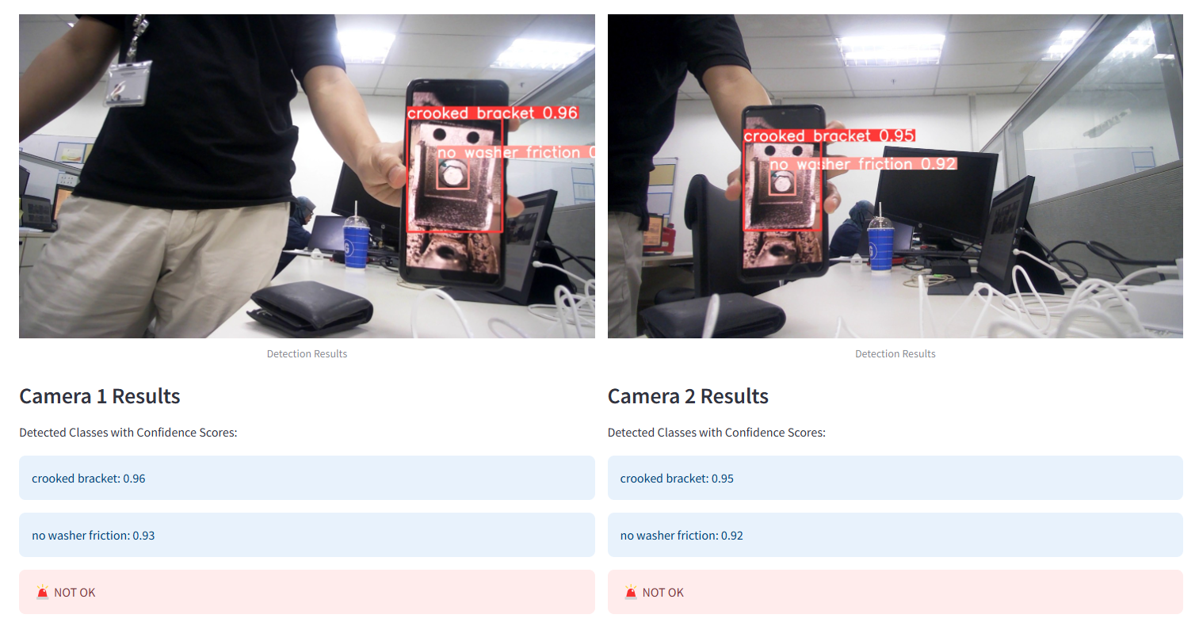

Figure 2.24 Detected result information displayed

1. After we have detect the results, we are able to store the results by inserting the data into the sidebar as shown in figure 2.25.
2. Figure 2.26 shows the whole webpage for camera capture object detection.

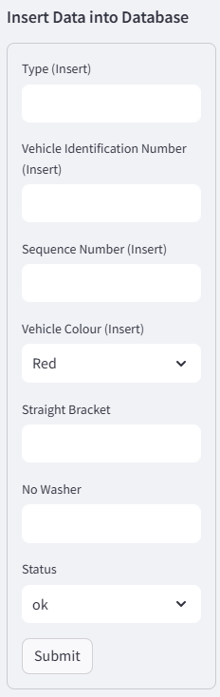

Figure 2.25 Insert data for data storage



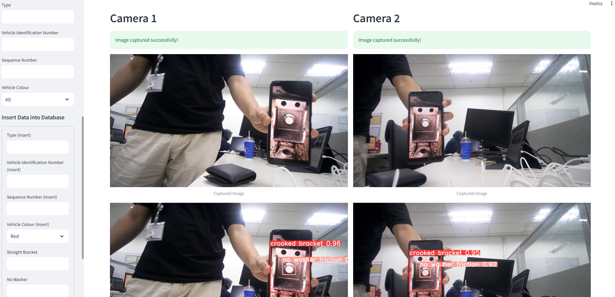 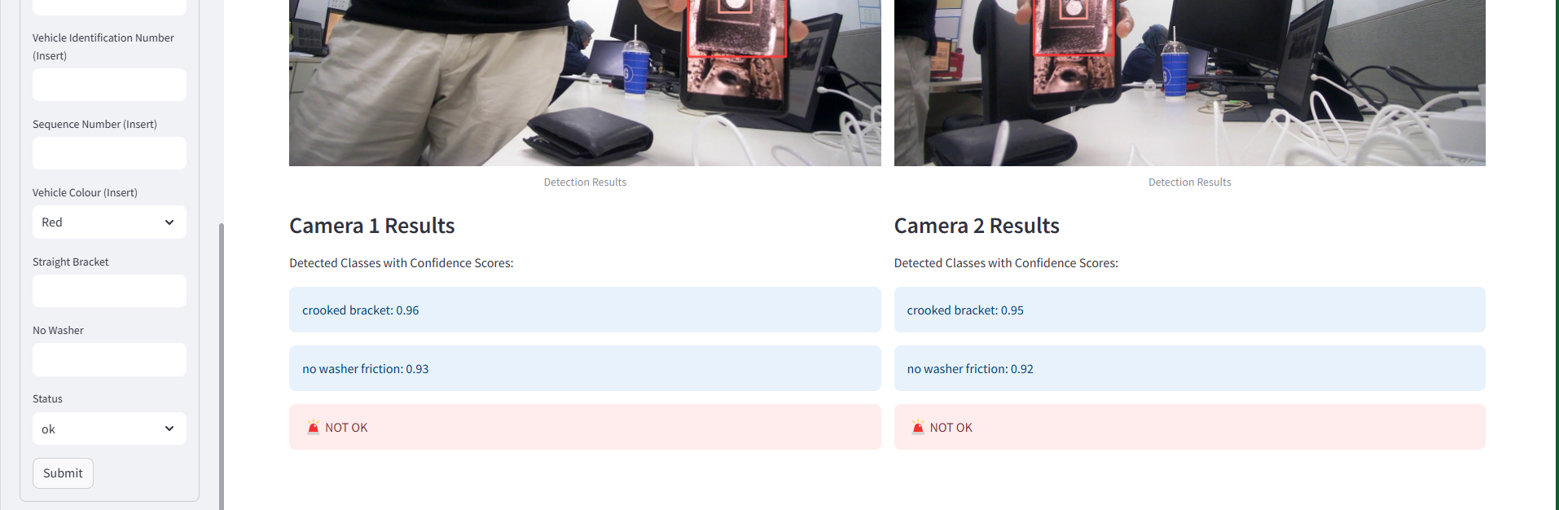

Figure 2.26 Camera capture object detection

## Live Object Detection

Webpage for streaming video footage and do object detection on it, this is for using webcam of the laptop currently but wireless live streaming footage can be implemented in this webpage if a higher processing speed of Raspberry Pi is used.

1. Beginning with the data table and bar chart displayed as shown in figure 2.27, we can filter the data table by inserting certain parameters in the query data input slot at the side bar and press enter.

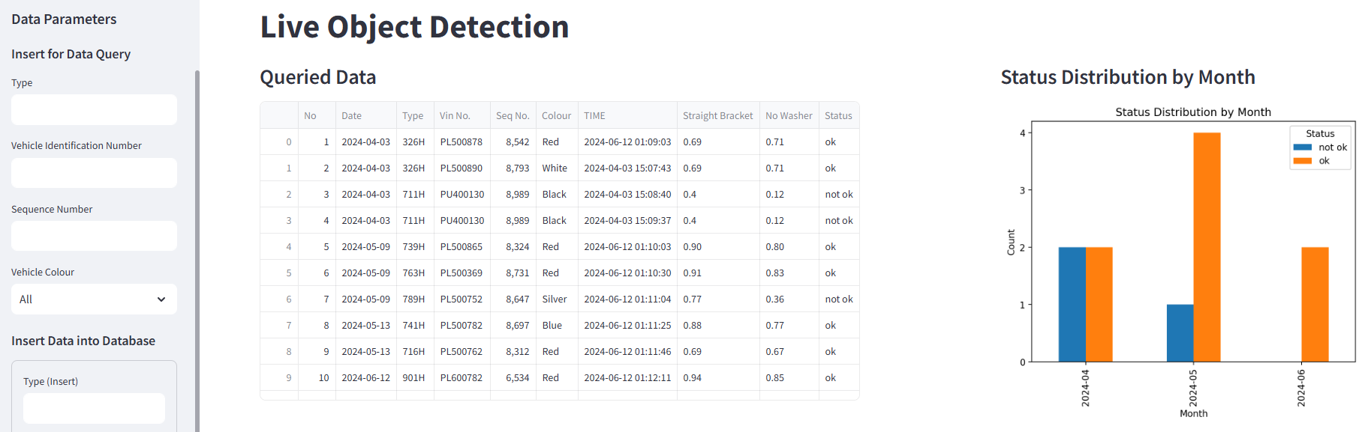

Figure 2.27 Data displayed for live object detection

1. Before starting the stream, we can adjust the confidence level to our desired value.
2. After that, we can start the stream by switching on the “Start/Stop Detection” toggle switch. Once the switch has been turned on, the streaming will open as shown in figure 2.28. We can see that the model is detecting through the stream.

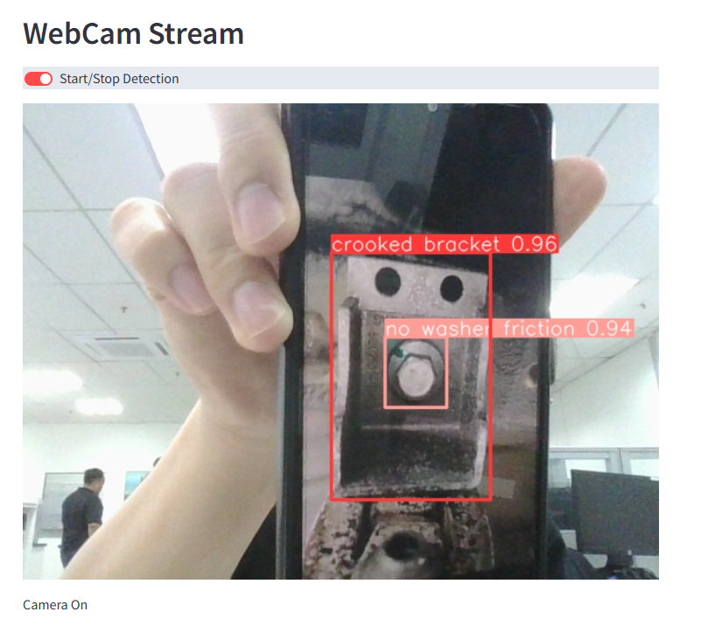

Figure 2.28 Object detection through live streaming

# Ambassador

For the next person handling the project, they must set up the system and test run for the first time to understand how it works.

Due to the data hotspot is different, we need to go inside the operating system of Pi Zero WH to connect to the new data hotspot. Connect the Pi Zero WH to a monitor and switch on the power source for the operating system to start, then we connect our mouse and keyboard (Bluetooth better). In the operating system, we connect to the new data hotspot as shown in figure 3.1. Also, we must forget the old data hotspot that has been connected before in the Pi Zero WH by selecting the “Edit Connections” from the “Advanced Options” in the menu as shown in figure 3.2, then we select the old data hotspot and remove it by clicking the minus sign as shown in figure 3.3. Importantly, we **must remember the IP address** from the new data hotspot WIFI we just connected and we can view the IP address as shown in figure 3.4 which is open from the “Connection Information” in “Advanced Options” menu. Do it for another Pi Zero WH also.

After we have connected and remember the new IP address, now we can turn on our Jetson Orin Nano (connect monitor, mouse and keyboard). Open the PyCharm project which consists of the project codes, we must replace the old IP address at codes of line 114, line 119, line 131 and line 136 from Capture Object Detection as shown in figure 3.5 to our new IP address (just the IP address at the middle of the URL link). After that, we can try and run the following command to open the system:

“streamlit run .\1_Homepage.py”

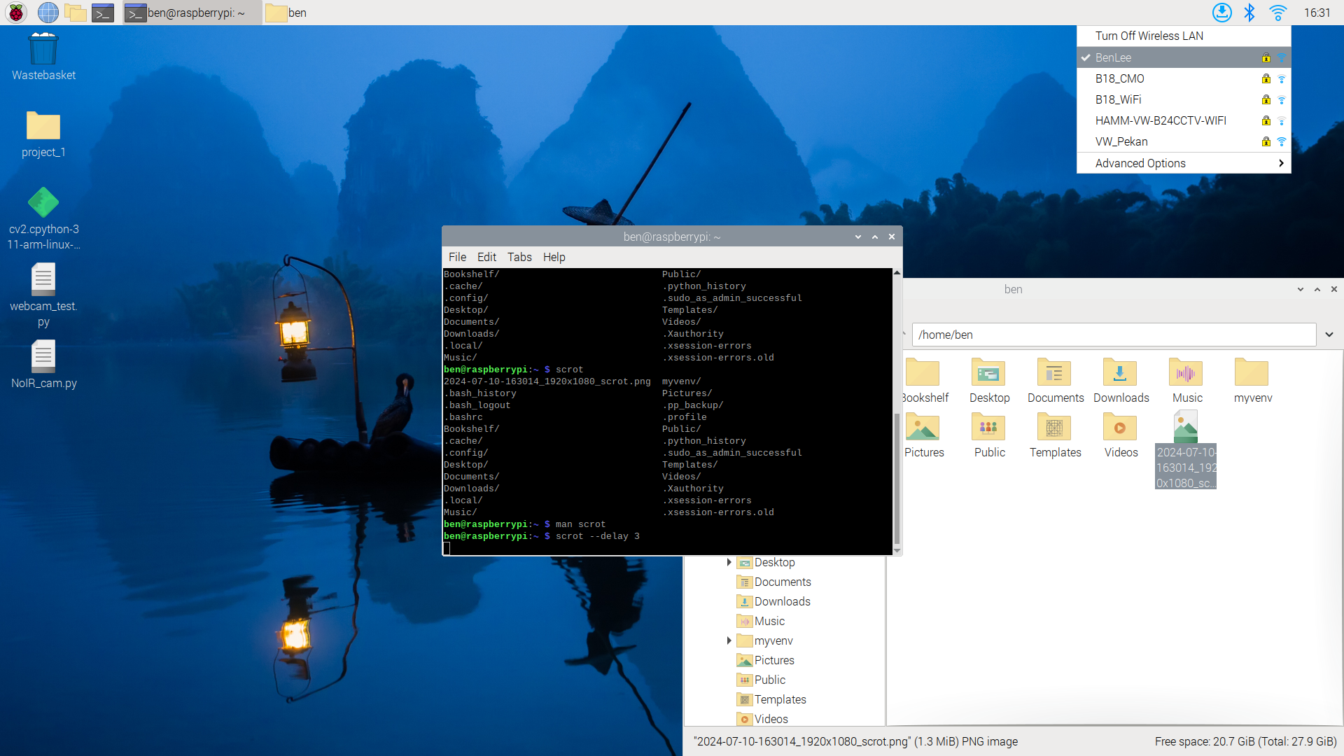

Figure 3.1 Selecting the new WIFI

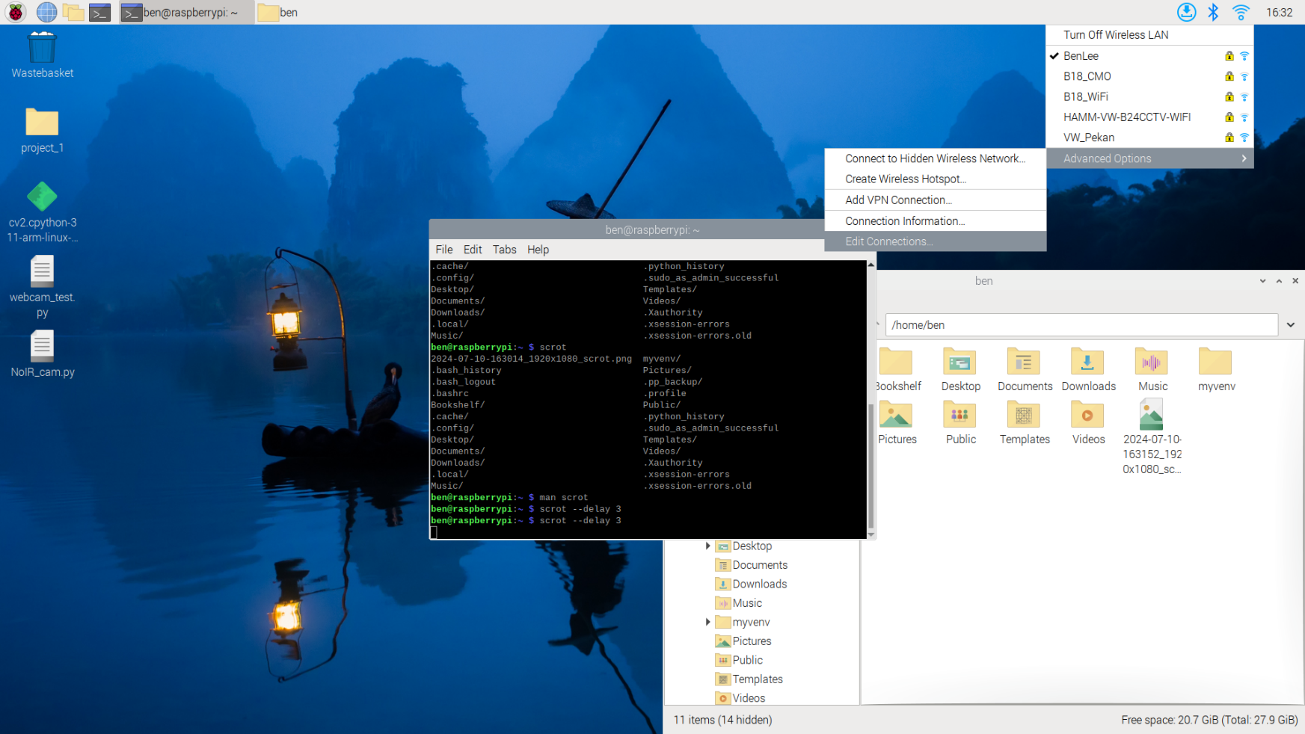

Figure 3.2 Selecting the edit connections

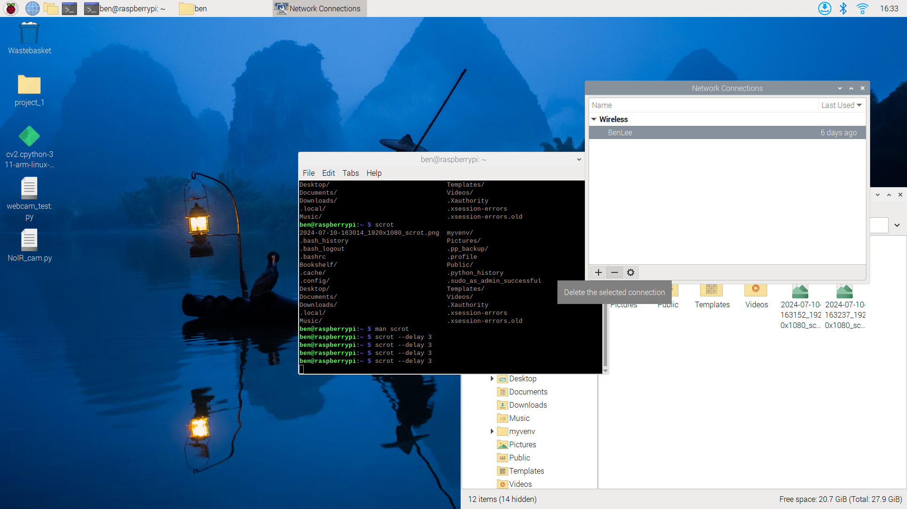

Figure 3.3 Removing of old data hotspot

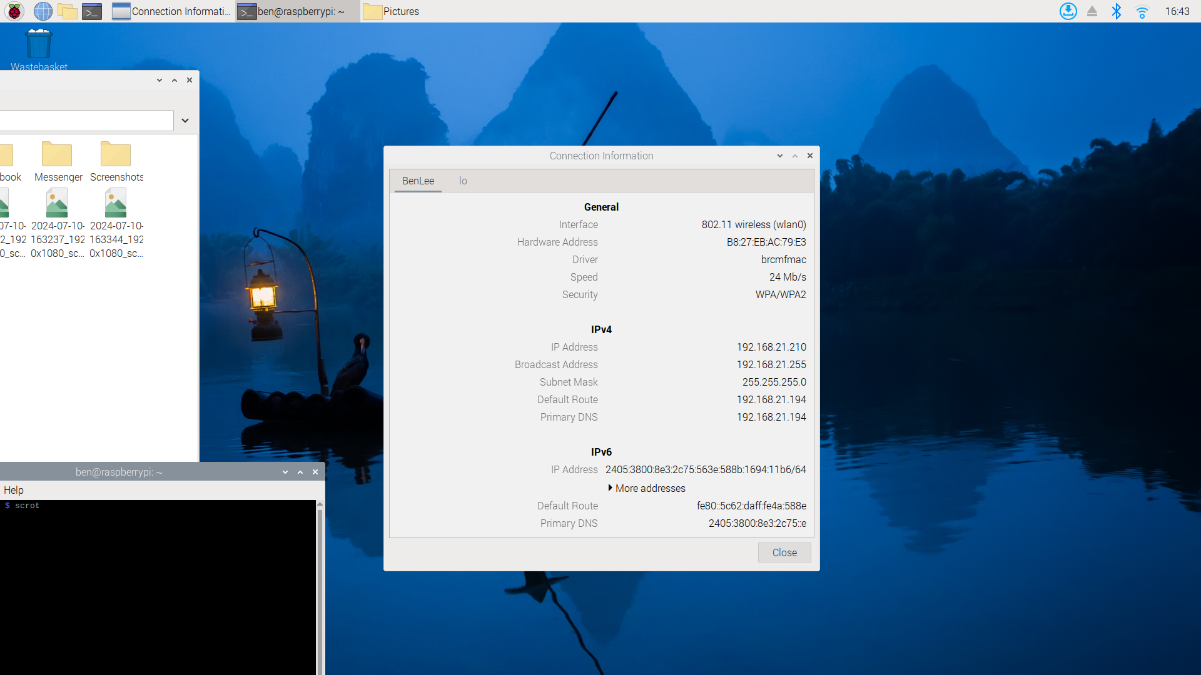

Figure 3.4 IP address from new data hotspot

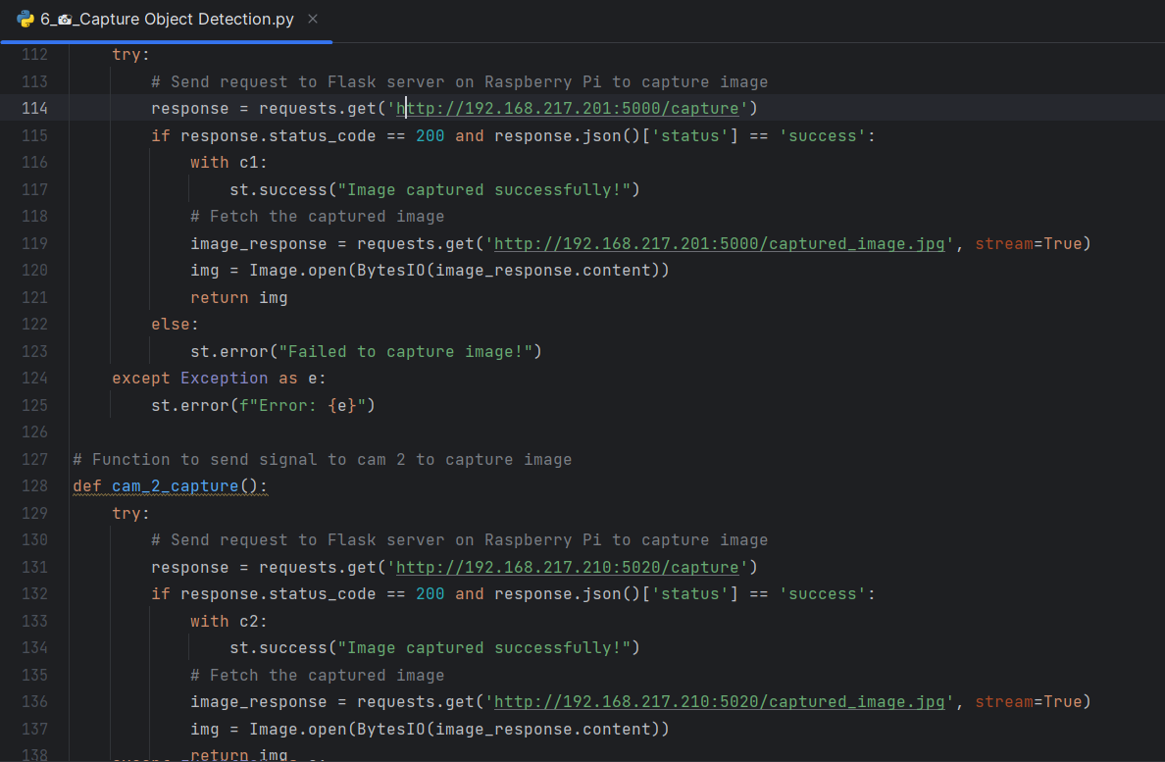

Figure 3.5 Capture Object Detection codes to be modify